
Web Technology Sessional Project Documentation.
The City Welfare Foundation
Course Code: CSE 324 — Web Technologies Sessional

Submitted by:
Md Ismail Hossain /1118052

Submitted to:
Yeakob Ali
Department of Computer Science & Engineering
Bangladesh Army International University of Science and Technology (BAIUST)
26 July, 2026

Obtained Mark

Frontend & Basic API Setup (40%) | Backend, Database & Authentication (30%) | Responsiveness (30%) | Total Mark

Table of Contents

1. Introduction 1
1.1 Background 1
1.2 Motivation 1
1.3 Problem Statement 1
1.4 Objectives 1
1.5 Scope of the Project 1
2. Literature Review / Related Work 1
3. Requirement Analysis 2
3.1 Functional Requirements 2
3.2 Non-Functional Requirements 2
3.3 Feasibility Study 2
4. System Design 2
4.1 System Architecture 2
4.2 Use Case Diagram 3
4.3 ER Diagram / Database Design 4
4.4 Data Flow Diagram 4
4.5 UI/UX Wireframes 4
5. Technology Stack 4
5.1 Frontend Technologies 4
5.2 Backend Technologies 4
5.3 Database 4
5.4 Tools & Frameworks 4
6. Implementation 5
6.1 Module Description 5
6.2 Key Features 5
6.3 Code Snippets / Algorithms 5
6.4 Screenshots 6
7. Testing 7
7.1 Test Plan 7
7.2 Test Cases & Results 8
8. Results and Discussion 8
- 9. Challenges Faced 8
10. Future Enhancements 8
11. Conclusion 9
12. References 9
Appendix 9
A. Source Code 9
B. User Manual 9

1. Introduction
1.1 Background
In traditional scholarship exam management systems, students and administrators face significant procedural delays due to manual paperwork, physical registration forms, cash-based fee collections, and manual admit card distribution. "The City Welfare Scholarship Portal" is a modern web-based application designed to digitize the entire scholarship lifecycle—from student registration and online fee verification to automated admit card PDF generation.
1.2 Motivation
The core motivation behind this project is to simplify the scholarship application workflow for students in Chittagong, Bangladesh. By providing an intuitive, transparent, and responsive digital portal, students can easily apply, track payment status, and download official admit cards without visiting physical distribution centers.
1.3 Problem Statement
Traditional paper-based scholarship application systems suffer from:
- High operational costs and excessive paper usage.
- Errors during manual record processing and roll number allocation.
- Difficulty in tracking payment status (TrxID) for applicant verification.
- Delays in distributing admit cards to thousands of participating students.
1.4 Objectives
- To build a secure role-based web application (Student, Ambassador, Admin).
- To automate payment verification via TrxID tracking (bKash/Nagad/Rocket).
- To auto-generate dynamic Admit Cards in PDF format upon admin approval.
- To provide a real-time responsive dashboard for applicants.
1.5 Scope of the Project
The scope includes:
- Students: Registration, exam selection, fee submission, admit card download, and support messaging.
- Ambassadors: Unique referral code tracking for student onboarding.
- Admins: Approving/rejecting registrations, managing exam circulars, and monitoring system analytics.
2. Literature Review / Related Work
Existing scholarship management solutions often rely on static web forms or third-party survey forms (like Google Forms), which lack automated backend roll generation, instant PDF admit card generation, and automated TrxID payment validation. Specialized LMS platforms can be overly complex and expensive. The City Welfare Portal fills this gap by offering a custom tailored Django-powered architecture designed specifically for competitive regional scholarship programs.
3. Requirement Analysis
3.1 Functional Requirements
- User Authentication: Role-based access control (Student, Ambassador, Admin).
- Exam Management: Admin can create scholarship exams with dates, fees, and deadlines.
- Application & Payment: Students apply for exams and input TrxID, payment method, and amount.
- Approval & Admit Card: Admin verifies registration and approves it. The system automatically creates an Admit Card PDF with a unique Roll Number.
- Messaging/Support: In-app messaging system between students and support admins.
3.2 Non-Functional Requirements
- Performance: Fast page load time with lightweight CSS/JS assets.
- Security: CSRF protection, secure password hashing (PBKDF2), and SQL injection prevention via Django ORM.
- Usability: Responsive Mint & Forest Green UI optimized for mobile and desktop screens.
- Scalability: Modular architecture allowing seamless integration of online payment gateways (SSLCommerz/bkash API) in the future.
3.3 Feasibility Study
- Technical Feasibility: Developed using Python/Django, HTML5, CSS3, JS, and SQLite—all highly reliable open-source technologies.
- Operational Feasibility: Minimal training required for admins; user-friendly UI for students.
- Economic Feasibility: Highly cost-effective due to open-source libraries and automated PDF generation (ReportLab).
4. System Design
4.1 System Architecture
The application follows the Model-View-Template (MVT) architectural pattern:
- Model (Database): Handles data structure (Exam, ExamRegistration, Payment, AdmitCard, CustomUser).
- View (Business Logic): Processes business rules, payment state validations, and PDF processing.
- Template (UI Layer): Renders dynamic HTML using Django Template Language (DTL) and CSS.

4.2 Use Case Diagram
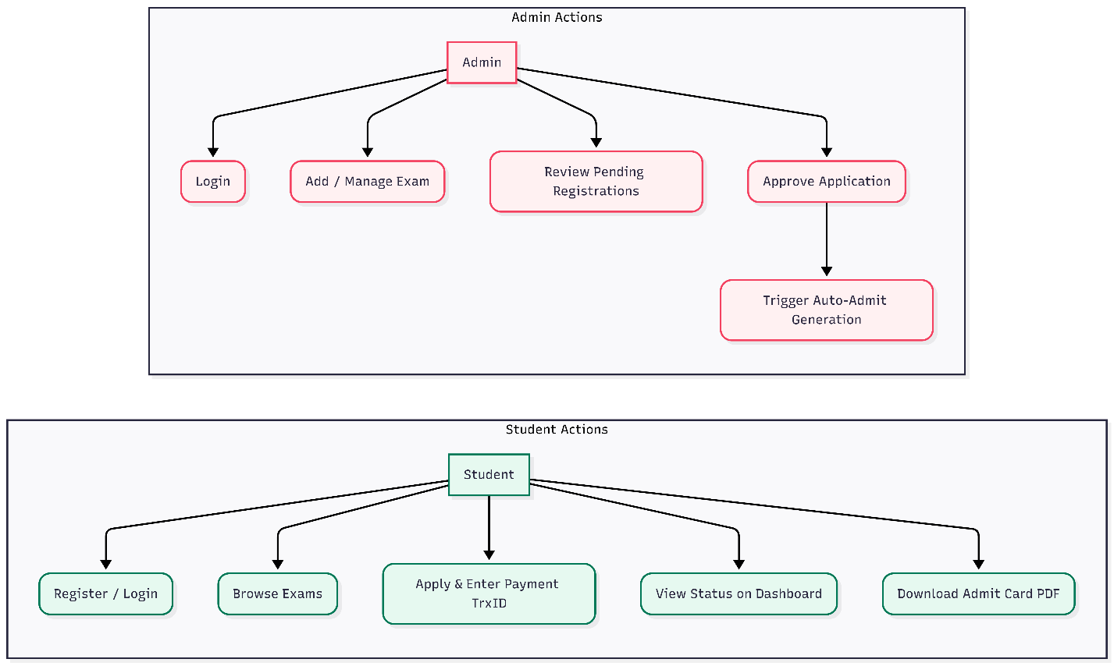

- Student: Register/Login -> Browse Exams -> Apply & Enter Payment TrxID -> View Status on Dashboard -> Download Admit Card PDF.
- Admin: Login -> Add Exam -> Review Pending Registrations -> Approve Application -> Trigger Auto-Admit Generation.
4.3 ER Diagram / Database Design
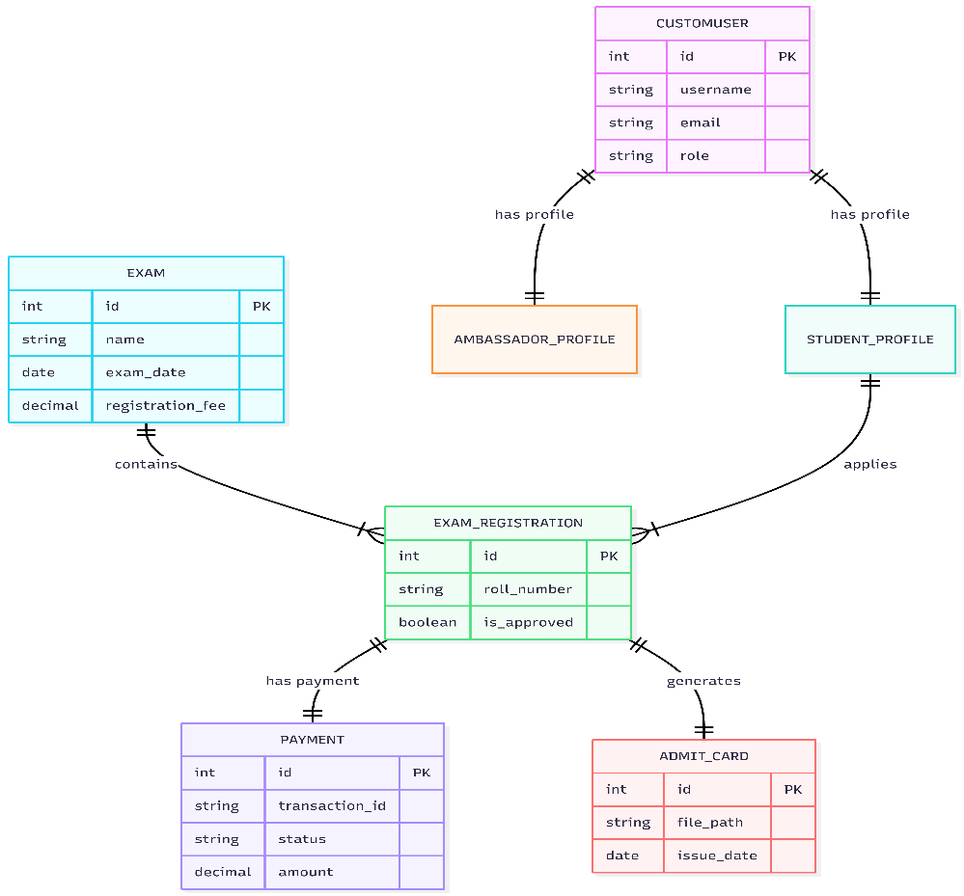

Key Entities and Relationships:
- User (CustomUser): One-to-One with Student/Ambassador profiles.
- Exam: One-to-Many with ExamRegistration.
- ExamRegistration: One-to-One with Payment and AdmitCard.
4.4 Data Flow Diagram (DFD)

- Level 0: Student submits application data & TrxID -> System processes data -> Admin approves -> System returns Admit Card PDF.
- Level 1: Detailed flow through Django Views, Database Models, Signal Triggers, and ReportLab PDF Engine.
4.5 UI/UX Wireframes
- Modern Mint & Forest Green theme (#047857, #e6f9f0).
- Glassmorphism navigation headers and responsive card layouts.
5. Technology Stack
5.1 Frontend Technologies
- HTML5 & CSS3: Custom responsive layout (style.css).
- JavaScript (ES6): Real-time countdown timer, dynamic DOM elements, mobile navbar toggle.
- FontAwesome 6 & Google Fonts: Icons and Hind Siliguri / Inter typography.
5.2 Backend Technologies
- Python 3.12
- Django 6.0 / 5.x Framework: Core web framework.
- ReportLab: Python PDF generation library for instant admit card rendering.
5.3 Database
- SQLite / PostgreSQL: Relational database management system.
5.4 Tools & Frameworks
- IDE: Visual Studio Code.
- Version Control: Git & GitHub.
- Environment: Virtualenv (Python Virtual Environment).

6. Implementation
6.1 Module Description
- Accounts Module: Manages registration, authentication, and user roles.
- Exams Module: Circular creation, exam dates, syllabus details, and fees.
- Students Module: Dashboard handling applications, roll number tracking, and payment statuses.
- Admit Card Module: Automated PDF generation containing student roll, exam venue, and photo layout.
- Payments Module: TrxID recording, payment validation, and status toggles (PENDING -> PAID).
6.2 Key Features
- Dynamic Live Countdown to Registration Deadlines.
- Auto-generating PDF Admit Cards upon Admin Approval.
- Real-time Payment & Approval Status Badges (Approved, Pending, Locked).
- Ambassador referral tracking system.
6.3 Code Snippets / Algorithms
Admit Card Generation Handler (admitcard/utils.py):
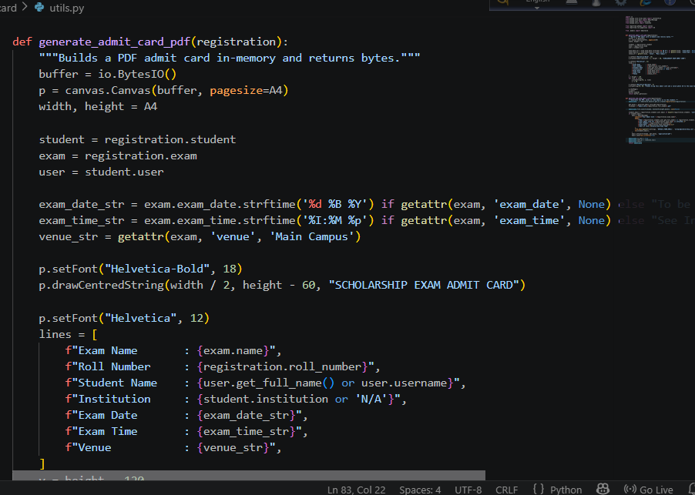

6.4 Screenshots



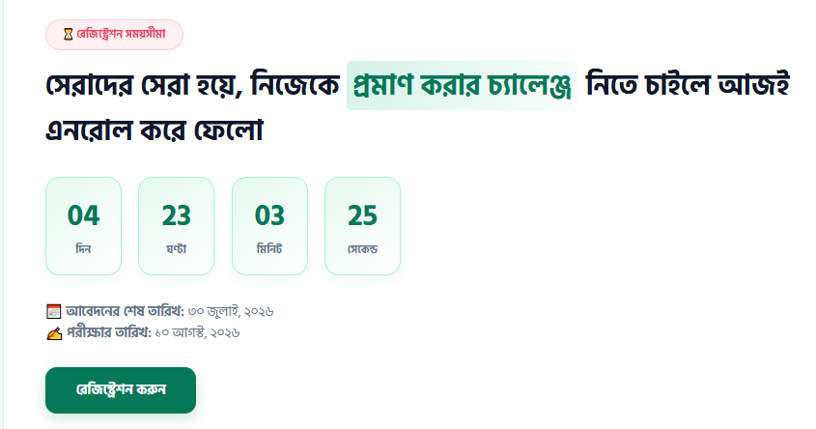

Figure:6.1: Home Page
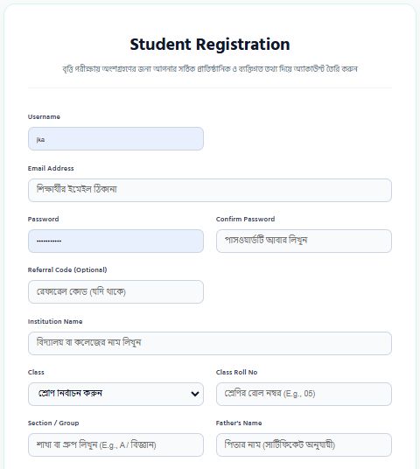

Figure:6.2: Registration Page

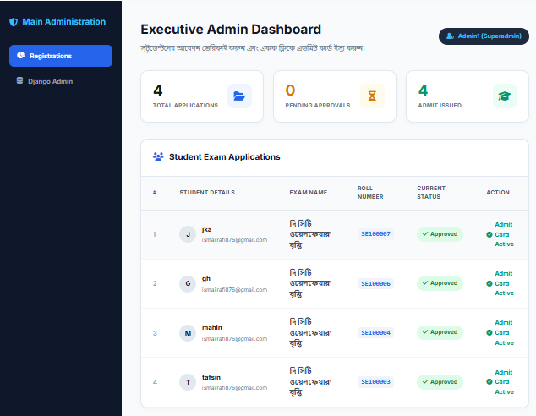

Figure:6.3: Admin Dashboard

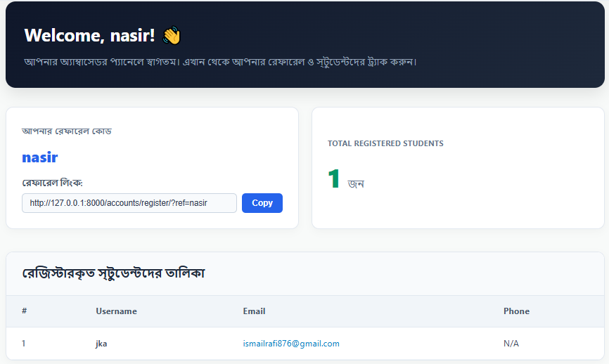
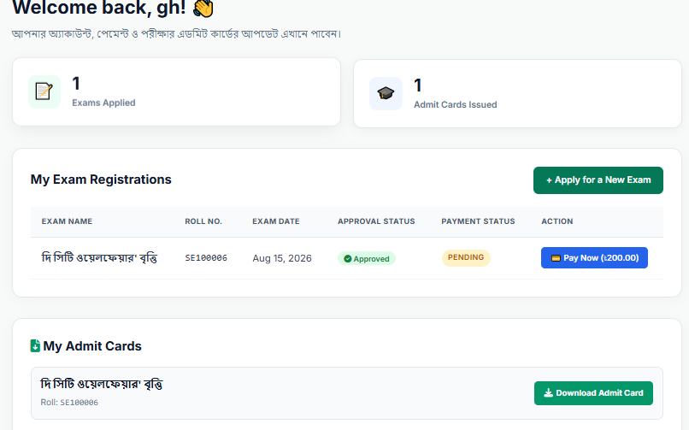

v

Figure:6.4: Ambassador Dashboard Figure:6.5: Student Dashboard

7. Testing
7.1 Test Plan
Testing was performed using Black-Box Testing to verify functionality across user authentication, database operations, payment state transitions, and PDF rendering.
7.2 Test Cases & Results
Test ID | Feature Tested | Input / Condition | Expected Output | Status
TC-01 | User Registration | Valid email, password, profile info | Account created, redirected to dashboard | PASS
TC-02 | Exam Application | Valid TrxID & Exam Selection | Registration created with status Pending | PASS
TC-03 | Admin Approval | Admin clicks "Approve" button | Status updates to Approved & triggers PDF generation | PASS
TC-04 | Admit Card Access | Unapproved student attempts download | Button displays Locked (Needs Admin Approval) | PASS
TC-05 | PDF Generation | Approved registration | PDF generated with Roll Number & Download link enabled | PASS
8. Results and Discussion
The implemented Scholarship Exam Portal successfully automates paper-heavy manual tasks. During testing, student registration time dropped significantly, and administrators were able to verify payments and release admit cards within seconds.
9. Challenges Faced
- Circular Import Issues in URL Configuration: Solved by correctly structuring app namespaces (admitcard:view_admit).
- Handling Dynamic PDF Rendering: Resolved by leveraging ReportLab and Python BytesIO stream buffer without writing permanent temporary files to disk before saving.
- Database State Syncing: Ensured that AdmitCard objects are created seamlessly when registration approval state toggles to True.
10. Future Enhancements
- Integrating SSLCommerz/bKash Payment Gateway API for real-time auto payment validation.
- Adding SMS notification updates upon admit card approval.
- Automated Merit List & Result Publication Module.
11. Conclusion
The City Welfare Scholarship Exam Portal provides a comprehensive digital solution for competitive examination management. By reducing administrative workload and delivering a seamless student user experience, the system fulfills all designed goals and demonstrates robust architecture built on Django.
12. References
- Django Documentation: https://docs.djangoproject.com/
- ReportLab PDF Generation Library Guide.
- Python 3 Documentation and Software Engineering Best Practices.
Appendix
A. Source Code
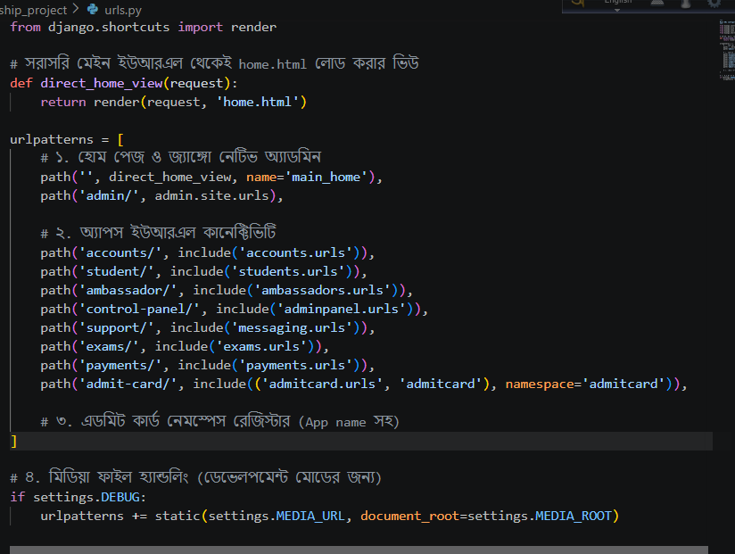
The core source code modules are organized under:
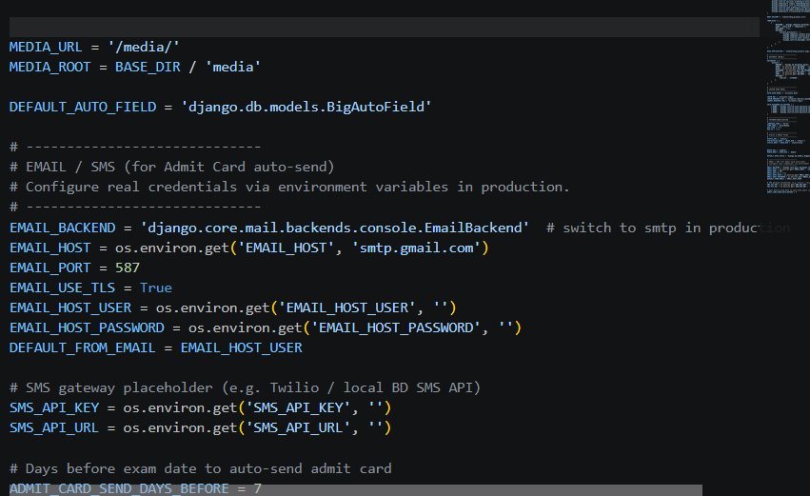

The project source code is organized into the following Django modules:
- scholarship_project/: Main system configuration and URLs.
- accounts/: User login, registration, and roles.
- exams/: Exam circulars and syllabus.
- students/: Dashboard, application, and TrxID entry.
- admitcard/: Auto PDF Admit Card generation.
- adminpanel/: Admin review and payment approval.
- templates/ & static/: HTML, CSS, and JS files.
B. User Manual

How to use this:

Step 1: Accessing the Admin Dashboard
- Navigate to the secure URL: /control-panel/admin-dashboard/.
- Enter your administrator username and password to authenticate into the system.

Step 2: Managing Exam Circulars
- To create a new scholarship exam:
  - Click on "Add New Exam" from the admin sidebar.
  - Enter the Exam Name, Syllabus Details, Exam Date, Time, Venue, Fee Amount, and Registration Deadline.
  - Click Save to publish the circular live on the portal.

Step 3: Reviewing Student Applications
- From the main dashboard, navigate to the "Pending Applications" or "Registration List" section.
- View incoming student submissions along with their submitted:
  - Student Name, Roll Number Candidate Code, Class, and School.
  - Selected Payment Gateway, Sender Phone Number, and Transaction ID (TrxID).

Step 4: Payment Verification & Approval
- Verify the student’s TrxID against your merchant statement (bKash/Nagad statement).
- Click the "Approve" button next to the student's record.
- Automated Backend Actions Triggered:
  - Application status updates to Approved.
  - Payment status toggles to PAID.
  - The ReportLab engine automatically generates a PDF Admit Card with a unique Roll Number.
  - The download link immediately becomes accessible on the student's dashboard.

